Agile Group Project

By

Gurpreet Singh

Inderjeet Singh

Deepak

Ashwini

Jugraj Singh

Contents

Introduction 3

Project Members 3

Agile Methodology 4

Pages and Mock-ups 5

Landing/Start Page 5

Home 6

Popular Events Page 6

Search Event Page and Search Result Page 7

Search Event Page with Location 8

Search Event Detail Page 9

Free Events Page 10

Free Event Detail Page 11

Paid Events Page 12

Paid Event Detail Page 13

Conclusion 14

# Introduction

The main goal of this project is the design of an agile / scrum mobile application. We have created an application for finding the Events using RestSharp Library. RestSharp is an all-round HTTP client library open source that deals with DotNet technologies of all kinds. This enables flexible applications to be developed by enabling integration to public APIs and fast access to data without the hassle of dealing with raw HTTP requests. RestSharp blends many benefits with a clean, simple interface, making it one of today's hottest REST devices.

The REST architecture with its easy API and efficient library is the alternative of developers searching for comprehensive applications and programmes. RESTful architecture offers a resource-oriented information-driven approach to web application development. It also provides joint tasks as configurable options, such as URI generation, payload parsing and encryption, to ensure that application developers are no longer concerned with low-level tasks, such as networking.

In this Event Finder application, a user can search various events around. Also, the events on a particular location or within the city. With the help of RestSharp Library user can directly access the information about events from the internet.

# Project Members

In order to increase the effectiveness of the application, five team members are participating in a different role that is given in the below table:

|  |  |
| --- | --- |
| Name of team Member | Role |
| Gurpreet Singh | Team Leader |
| Inderjeet Singh | Front End Developer |
| Jugraj Singh | Web Designer |
| Deepak | Back End Developer (API) |
| Ashwini | Application Tester |

All members make their own attempts to successfully complete the project and to meet the needs of the client by submitting an application Event Finder

# Agile Methodology

The agile approach is used as an alternative to traditional methods in this project. This strategy is very effective and pragmatic and addresses the changing needs of the technology. It is cost effective, quick and delivers ongoing changes.

Our group used the agile / scrum approach here in this project. At the start, the team members define and address all criteria. The team then decided to implement the special feature in the Event Finder application so that it could meet users ' needs.

Several improvements to the application have been made to make it more user-friendly and appealing on user's suggestion. After all improvements have been introduced and applied, the app is available for use by the consumers.

# Pages and Mock-ups

## Landing/Start Page

This is a landing page of the application which appears only for few seconds. It contains an image and name of the app as Eventure, it reroutes to the home page.

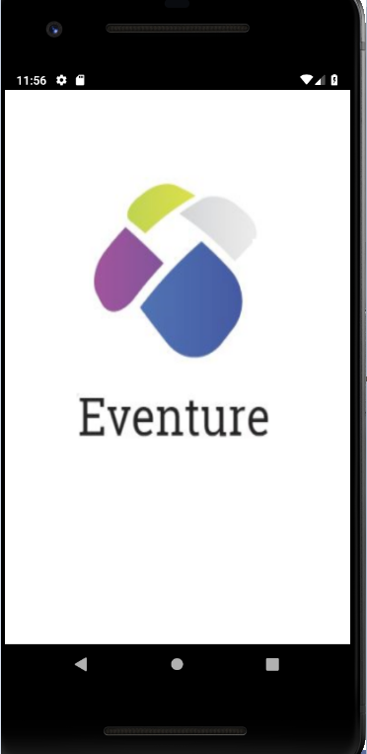

## Home

This is the main page of the application. On this page there are three buttons Popular, search and Nearby. Whenever user wants to know the popular events around he/she can click on the popular button and need to add location, the application will display all relevant events in that location. If user wants to search for the events nearby, he/she can use the nearby button to find the information. The search button is helpful in finding the events with in the city.

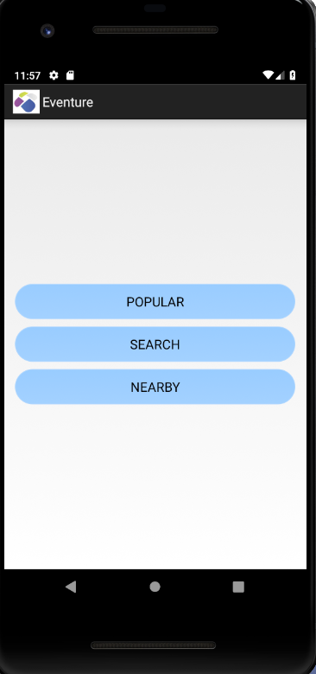

## Popular Events Page

This page will highlight all the popular events within the city.

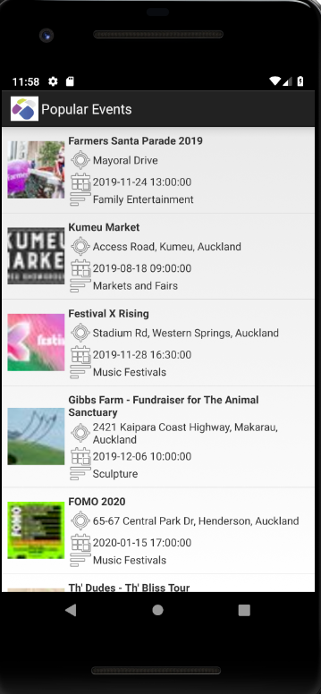

# Search Event Page and Search Result Page

With the help of this page user can search the free as well as paid events by adding the location and category of their choice. When user enters the location and click on search button the search results page displays the various events around.

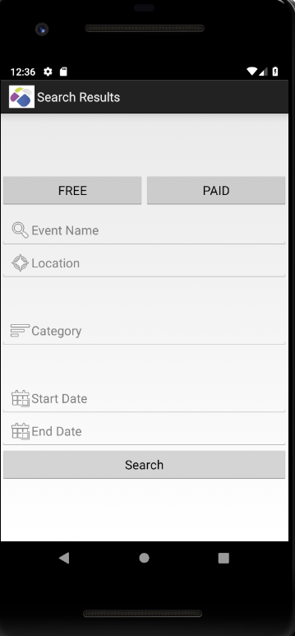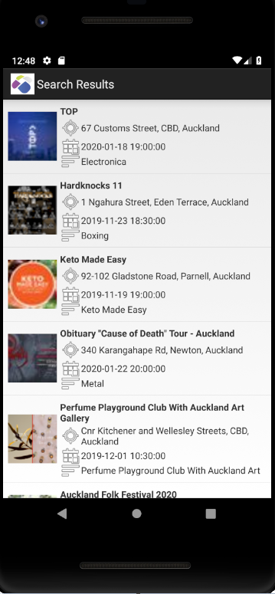

## Search Event Page with Location

User can use the location to find various paid and unpaid events around.

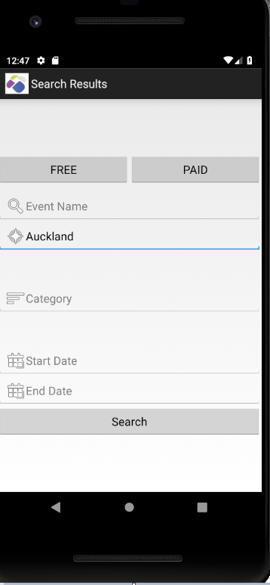

# Search Event Detail Page

Once user clicks on a particular event, he/she can access the details of that events with the help of Search event detail page.

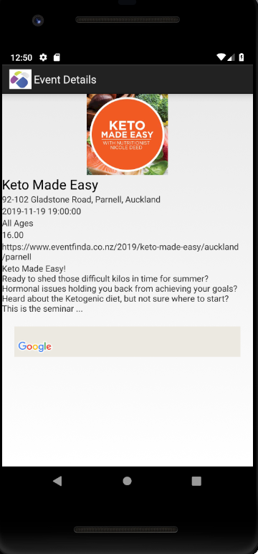 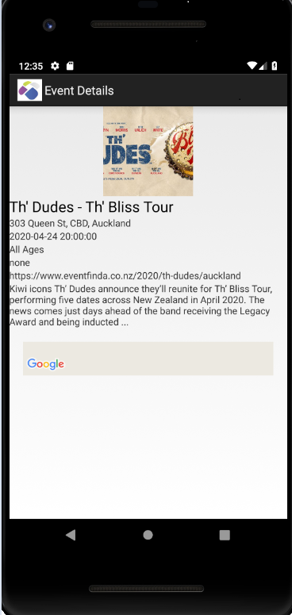

# Free Events Page

While searching for events when user select free events button. The Free Event page displays the free events in that location entered by the user.

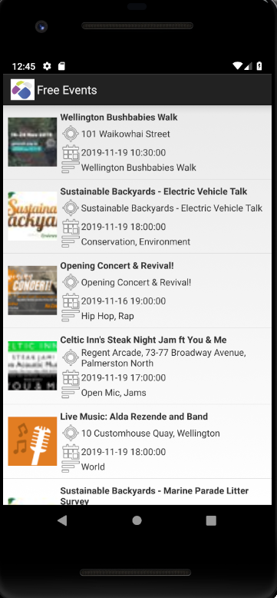

# Free Event Detail Page

If user wants to access the details of the particular event of his or her choice. User needs to click on the event and the free event detail page will display the details of that event.

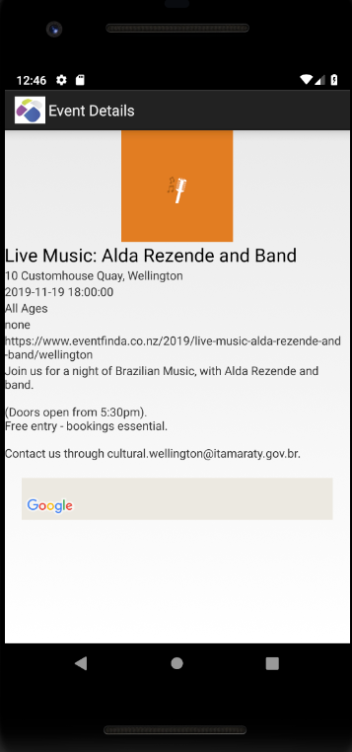

## Paid Events Page

While Searching for the events, if user selects the paid event based on a particular location, then this app will display the paid event in that location. The Paid Event page will display the information.

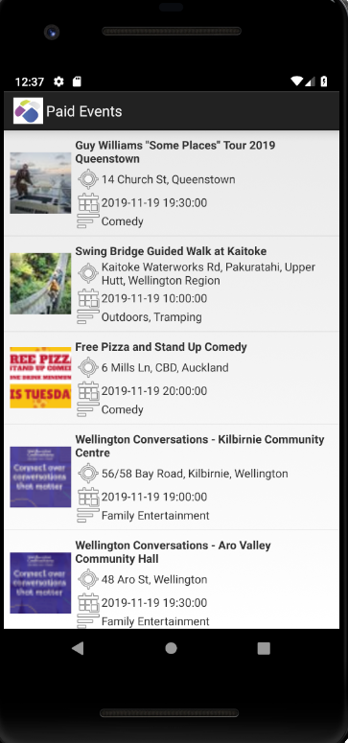

## Paid Event Detail Page

If user wants to access the details of the particular paid event of his or her choice. User needs to click on the event and the paid event detail page will display the details of that event.

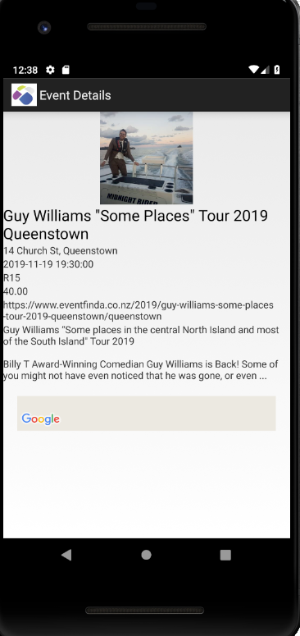

# Conclusion

In brief, this project is based on an agile scrum approach, in which the IT group developed the Android application known as Event Finder.